**Module 1: Graded Quiz**

**LATEST SUBMISSION GRADE**

83.33%

1.

Question 1

**Scenario 1: You’re at home and need to drive to work**

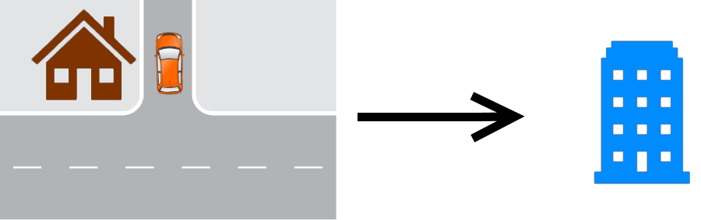

During the trip, you will be performing OEDR tasks. Of the tasks below, which of the following is **not** an example of OEDR?

**1 / 1 point**



Stopping at a red light



Slowing down when seeing a construction zone ahead



Pulling over upon hearing sirens



Maintaining a distance to a vehicle ahead

**Correct**

Correct! Maintaining distance is not a detection and reaction procedure, it is a normal driving behavior.

2.

Question 2

Which of the following tasks are associated with **perception**?

**1 / 1 point**



Planning routes on a map



Estimating the motion of other vehicles

**Correct**

Correct! Estimating the motion of other vehicles is associated with perception



Responding to traffic lights



Identifying road signs

**Correct**

Correct! Identifying road signs are associated with perception

3.

Question 3

Before leaving, you decide to check the weather. The forecast states that over the next few days there will be both sun and rain along with some fog. Assuming your vehicle exhibits Level 5 autonomy, which of the following **weather conditions** can your vehicle operate?

**1 / 1 point**



Clear and sunny



Windy heavy rainfall



Heavy Fog



Light rainfall



All of the above

**Correct**

Correct! Level 5 autonomy can operate in any weather condition.

4.

Question 4

You enter your autonomous vehicle and it drives your usual route to work. While the vehicle is driving, you decide to take a nap. For **which levels of autonomy** is this safe? (Select all that apply)

**1 / 1 point**



1



2



3



4

**Correct**

Correct! Only level 4 and 5 autonomy can handle emergencies autonomously.



5

**Correct**

Correct! Only level 4 and 5 autonomy can handle emergencies autonomously.

5.

Question 5

**Scenario 2:**(Assume the car is driving on the right-hand side of the road) .

You’re approaching an all ways stop sign and you want to make a right turn. Your vehicle is denoted in orange. There are 2 pedestrians currently crossing and another vehicle (denoted in green) approaching the stop sign from the left.

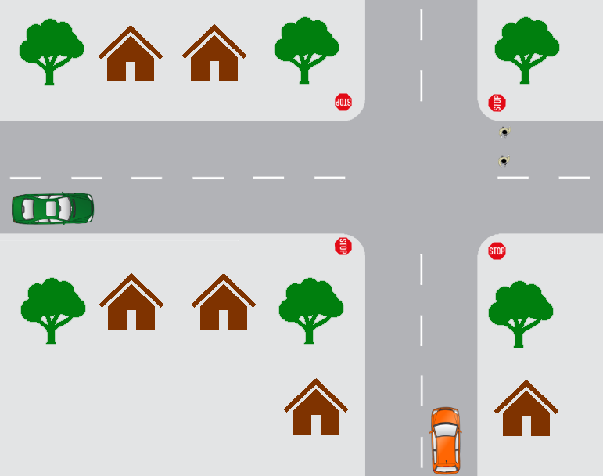

This task involves multiple considerations, which of them are **predictive planning**? Select all that apply.

**1 / 1 point**



Wait for the pedestrians to finish crossing before turning

**Correct**

Correct! Predictive planning deals with planning based on predictions of the actions of others.



At a stop sign, stop and look both ways before proceeding



The green car arrives at the stop sign after you and plans to travel straight through the intersection. You choose to move first.

**Correct**

Correct! Predictive planning deals with planning based on predictions of the actions of others.



Gradually decelerate while reaching the stop sign

6.

Question 6

Here are some rules for driving at a stop sign. Which of the following is an appropriate **priority ranking**?

1) For non all-way stop signs, stop at a point where you can see oncoming traffic without blocking the intersection

2) If there are pedestrians crossing, stop until they have crossed

3) If you reach a stop sign before another vehicle, you should move first if safe

**0 / 1 point**



1, 2, 3



3, 2, 1



2, 1, 3



3, 1, 2



1, 3, 2

**Incorrect**

Incorrect. Please review rule priority in lecture 3 on Driving Decisions and Actions.

7.

Question 7

Which of the following are **off-road objects**? (Select all that apply)

**1 / 1 point**



Curbs

**Correct**

Correct! These are examples of off road objects.



Road markings



Stop signs

**Correct**

Correct! These are examples of off road objects.



Pedestrians



Trees

**Correct**

Correct! These are examples of off road objects.

8.

Question 8

Suppose your vehicle has**lane keeping assistance**, which of these objects are relevant for its performance? (Select all that apply)

**1 / 1 point**



Stop signs



Road markings

**Correct**

Correct! Detecting road markings and curbs are needed for lane keeping.



Pedestrians



Trees



Curbs

**Correct**

Correct! Detecting road marks and curbs are needed for lane keeping.

9.

Question 9

Which of the following sensors are used for the **lane keeping assistance**? (Select all that apply)

**1 / 1 point**



Cameras

**Correct**

Correct! Detection and localization is needed for lane keeping.



LIDAR

**Correct**

Correct! Detection and localization is needed for lane keeping.



GPS

**Correct**

Correct! Detection and localization is needed for lane keeping.



IMU

**Correct**

Correct! Detection and localization is needed for lane keeping.



Barometers

10.

Question 10

**Scenario 3:**You are on the highway and you see a truck in front of you. Assume the car is driving on the right-hand side of the road. There is also a blue car beside the truck in the other lane.

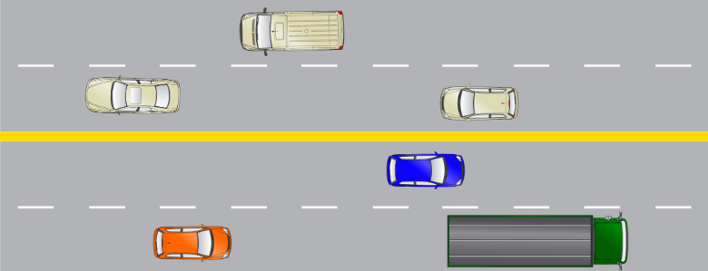

Your vehicle follows the truck and maintains a constant distance away. What kind of **control** is this?

**1 / 1 point**



Lateral



OEDR



Longitudinal



Fallback

**Correct**

Correct! Distance keeping is a longitudinal control problem.

11.

Question 11

You decide to **change lanes** to pass a truck. What kind of decision is this?

**0 / 1 point**



Short term planning



Long term planning



Reactive



Immediate



Rule-based planning

**Incorrect**

Incorrect. Please review decision making in lecture 3 on Driving Decisions and Actions.

12.

Question 12

Which of the following tasks are**rule-based planning**? (Select all that apply)

**1 / 1 point**



If there are vehicles directly beside us on the lane, it is unsafe to lane change.

**Correct**

Correct! Rule based planning only considers the present state, not what vehicles will do next.



During a lane change, maintain our current speed or accelerate slightly

**Correct**

Correct! Rule based planning only considers the present state, not what vehicles will do next.



If the vehicle in front is going to slow down sharply, then avoid performing a lane change.

13.

Question 13

Suppose the blue vehicle suddenly brakes and you decide to abort the lane change. If your vehicle can **respond automatically and remain in its own lane**, what is the minimum level of autonomy of your vehicle?

**1 / 1 point**



1



5



4



2



3

**Correct**

Correct! Level 3 autonomy can perform OEDR.

14.

Question 14

The blue vehicle returns to normal speed and you can now safely change lanes. Your car is **performing the lane change**, what kind of control is this?

**1 / 1 point**



Lateral



Fallback



OEDR



Longitudinal

**Correct**

Correct! Lane changing is a lateral control problem.

15.

Question 15

**Scenario 4:**You are almost at work but encounter a construction site.

Assume the car is driving on the right-hand side of the road. Your vehicle is denoted in orange.

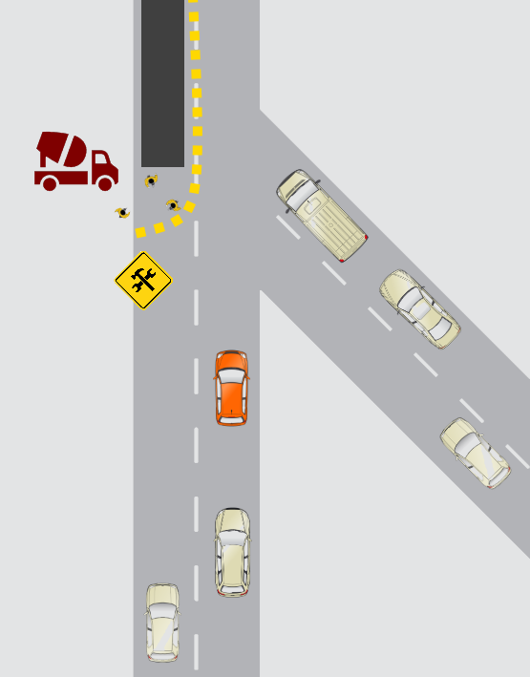

You see a construction site where the workers are repaving a road full of potholes. They are using jackhammers which can cause dust clouds.

You create the following decision tree for getting through the construction site. From the diagram, which of the following decisions should you make? **(green is true, red is false)**

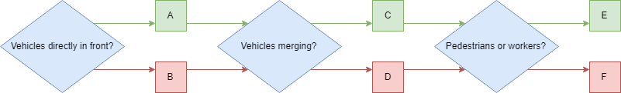

**1 / 1 point**



A (True)



B (False)

**Correct**

Correct!



C (True)

**Correct**

Correct!



D (False)



E (True)

**Correct**

Correct!



F (False)

16.

Question 16

Here are a set of rules for making these decisions,**arrange them in an appropriate prioritization**.

1) If there are no vehicles ahead, accelerate to the speed limit

2) Drive slowly in construction zones

3) If there are pedestrians or workers directly ahead in the current lane, stop

4) Yield to merging vehicles, if necessary

**1 / 1 point**



1, 2, 3, 4



2, 3, 4, 1



3, 4, 1, 2



3, 4, 2, 1

**Correct**

Correct! Prioritize safety in each case, yielding to pedestrians and then vehicles first, before defining acceptable travel speed.

17.

Question 17

**Scenario 5:** You’re finished work and need to drive back home, but it’s nighttime.



You plan a new path home on your GPS application to avoid the construction site, **what type of planning is this**?

**0 / 1 point**



Short term planning



Reactive



Long term planning



Rule based planning



Immediate

**Incorrect**

Incorrect. Please review types of planning in lecture 3 on Driving Decisions and Actions.

18.

Question 18

Your new path goes through a school zone and you see the school zone sign. You decide to slow down despite there being no pedestrians or children (it’s nighttime). What sort of **planning** is this?

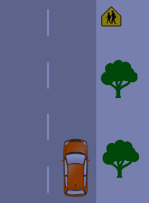

**1 / 1 point**



Rule based planning



Long term planning



Immediate planning



Reactive planning



Short term planning

**Correct**

Correct! The rule to slow down in school zones is being followed.